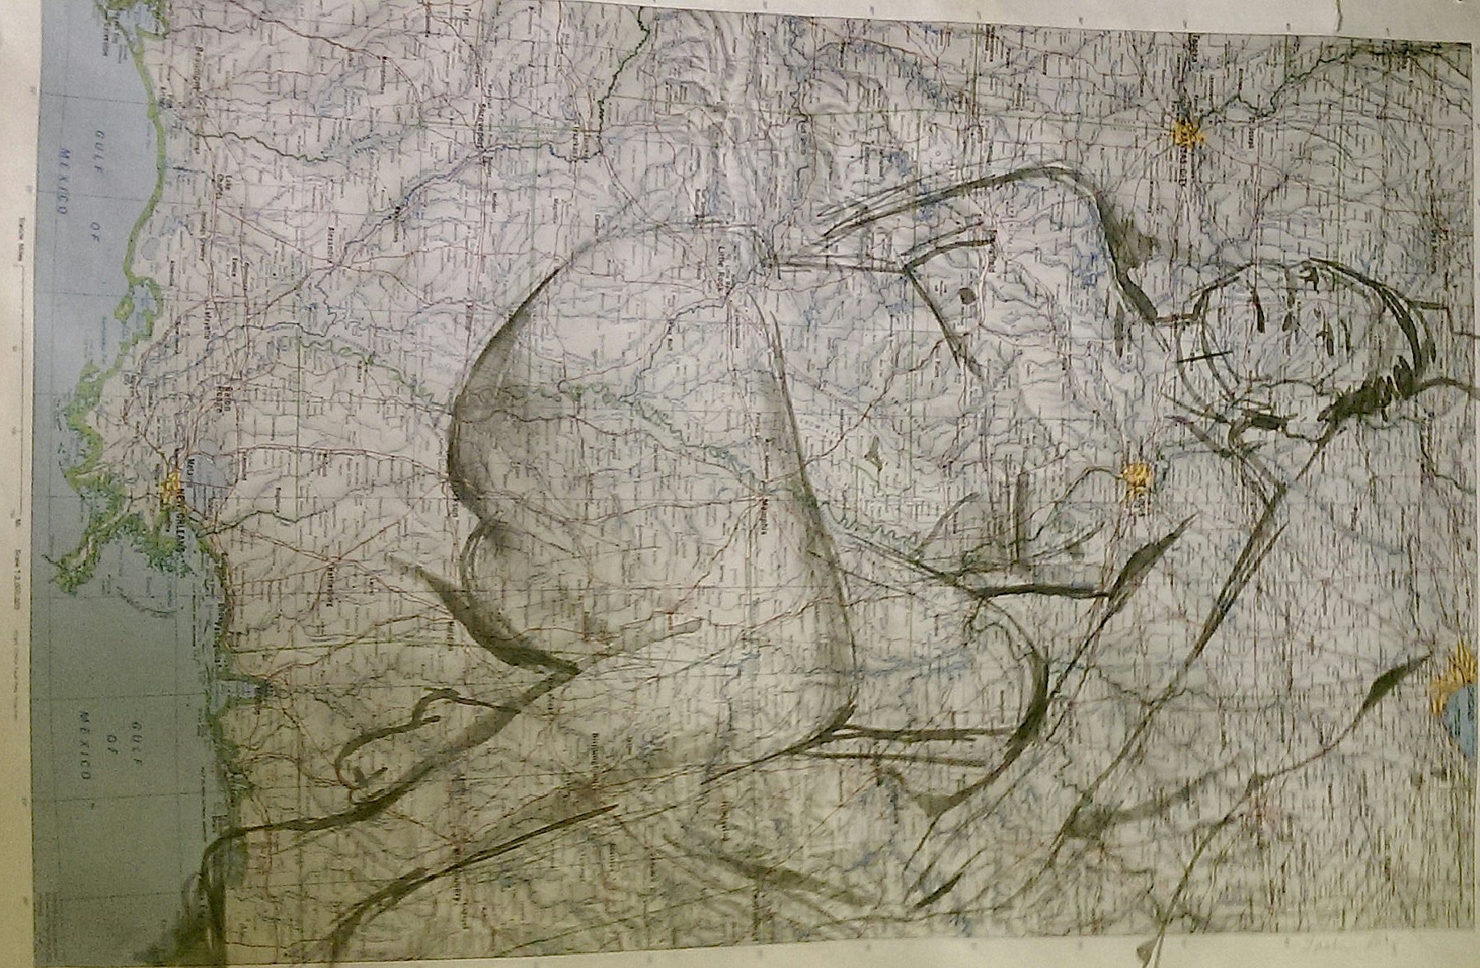

The Moment
Everything Changes

Sally DeJesus

Edited by:
Damien Tillman
whose compassionate commitment to
this work became the catalyst for it.

Cover art by:
Tasha Depp-Joy

Extra Special Thanks to:
Nick DeJesus &
Domingo DeJesus
for accepting and loving me as
I am.

Very Special Thanks to:
Deborah
Lynda
Lynne
Mary K.
Mary R.
Selma
Vicki
Virginia
for your endless support and friendship.

&
Acentos
Louder Arts
Union Square Slam
and the New York Public Library
for offering accessible places
to write and share poetry.

Dedicated to:
my parents TR, Jerry & Carol
& siblings Kevin, Will, Ben, Jake and Miranda
who each in their own unique way
inspire the light in me.

CONTENTS

-Part I- 3

Collision Course
Eleven
Where I’m From
Homework
Ostrich
Every Other Weekend
Aliens
Commune
Twelve

-Part II- 14

Eighteen
Costume Shop
Coney Island
Us
Atonement
The Party
Almost Dia de los Muertos

-Part III- 22

Where I Live
Journey’s Song
Safety Precautions
Fertilization
The Game
Invisible
What the Poem Can’t Do
Judge This One
A Letter to Myself
In Relation
The Moment Everything Changes

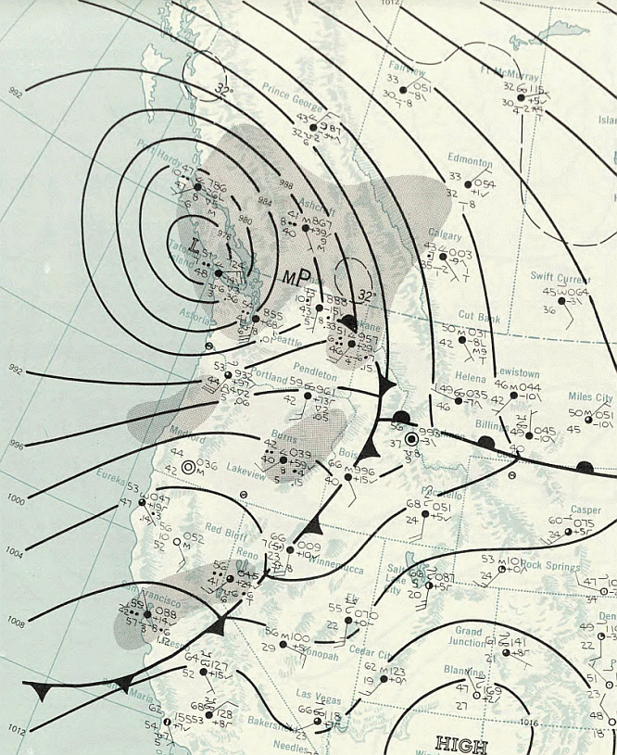

-Part I-

Collision Course

It was sensational
snow capped
ski length
impulsive pleasure
love at first sight in
Idaho,
known for its potatoes
at a bar
in Bogus Basin.

She moved from the west
with her two-year-old son
to fresh peaks in Boise.

He shipped from the east
with his passport
to Mountain Home
Air Force base.

They married ten
days later excited
phoned home
with the news
her mother was happy
his father hung up.

Belongings unpacked a year later
driving over railroad tracks in
New Haven
they were looking for the hospital
on a shortcut.

It was dark,
so dark they almost got lost.
I was close,
so close to being born in a Pontiac.

Eleven

Chubby
awkward
not as smart
as her brothers
smoking
stealing

5am she waits
for a yellow bus

as the sun
rises slowly
over a field of
strawberries
she will pick

for the money.

Where I’m From

I flatten and stretch silly putty
over photographs in the newspaper
as I discover how to bend and stretch
reality.

Comics are delivered with the paper
to the house
where we eat all the ice-cream
before dinner
when the power goes out.

Mom makes twenty
peanut butter and jelly sandwiches a week
leaves them in the freezer
for me and my brothers
she says
she likes things to be easy.

The newspapers read
the president, assassinated
civil rights leader, assassinated
a family unravels
as darkness descends
in the house where I’m from.

After the fights dad sneaks in to tell
me and my stuffed bear
whispered apologies.

The police arrive
in the house where I’m from.

Discarded but eventually rescued
photos of us
reveal happiness, sometimes
too.

Homework

2am the vacuum cleaner woke me up
the house had to be very clean
laundry folded
and dishes done.
Tonight mom said
she’s going to kill herself.

She explained what happens
when you breathe
car exhaust in a closed garage.

I asked if it would hurt,
It wouldn’t.

I followed mom
woke up in the morning
next to her
and neatly folded piles of
clothes.

She said,
Time for breakfast

I had more homework to do.
Ostrich

She fainted often at school.
Instructions were administered
by doctors and teachers:

Put your head down
between your legs
to get the blood back
in your brain.

Embarrassing, yes
but sometimes necessary.

She found the drugs in her
mom’s pink bunny costume
when she snuck in the closet
to try it on.

Every Other Weekend

I heard mom
scream
in the dark
once or twice
crept into
the living room
on hands
and knees
I see mom
with...

At dad’s house
I ask if she is staying over like
the other lady did
last time we visited.

His brow hits the ceiling as
I’m transported like Star Trek to
another room within seconds.

Mom picks us up
Dad drops us off
every other weekend
every other weekend.

Crashing off pedestals
our parents
come down.

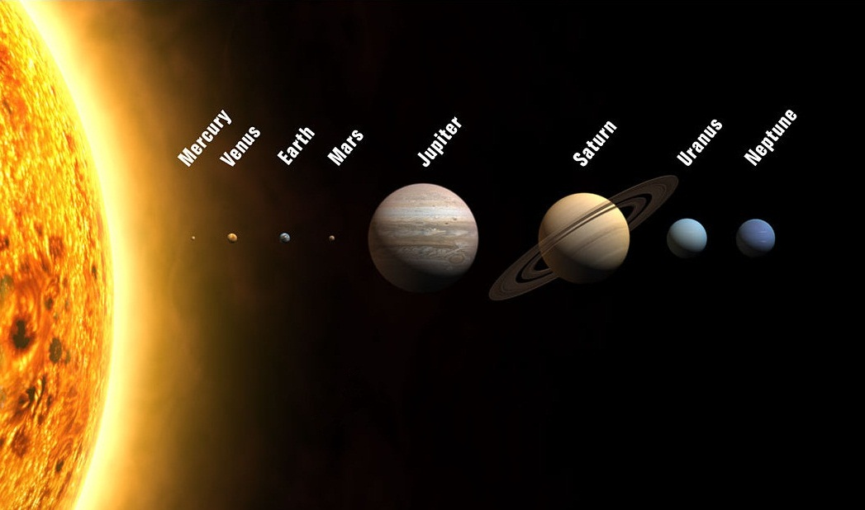
Aliens

Mom called us into the living room
she believed beings from other planets
were here.

Here’s what to do
if you see one:

First, show them open palms and say
“No weapons.”

Slowly pick up a stick and draw one large sun
and nine small circles in a row

Count to the third planet
stomp on the ground and say:

"This is Earth."

Slowly put the stick down and repeat,
“No weapons.”
Commune

Cheap enough for an average of twenty
some of whom slept on the floor
hitch-hikers, drifters, dropouts and siblings.

A nutritious snack
named after Hood
as in Mt. Hood
as in a mountain I visited
once or twice.

Salty two per-pod peanuts
passed around a wooden
picnic table
we were told to eat one-half cup daily
or else
we could die of hypoglycemia.

I didn’t believe it,
but ate them anyway.

Mom called it,
The First Cosmic Bank of Divine Economy
Drugs were welcome
Alcohol, forbidden.

Teens spun out on rusty stingray bikes
to deliver snacks in
one-half cup portions
to transitional housemates
working the night shift at
the taco place.

Shells
covered the floor the night when
police busted in
searched our rooms one by one
searched us one by one.

I held my little brother’s crying body
in my lap
as our outraged mother was handcuffed
and escorted to jail with
a pocket full of
‘Hoody’ peanuts.

Twelve

When I was twelve
dad remarried at the courthouse
me and my brothers
came over for the party.

My new stepmother
took me into his room
that would become her room.

She asked if she could
fix my hair.

On the back of the closet door
in a full length mirror
she stood behind me
gathered my hair up in
her hands and asked,
How should I fix it?

I wasn't sure how
to fix it.

She said nice things
about the awkward
reflection
as we noticed me
together
different than fat
stupid or
the problem.

I existed
in ways
I had not known.

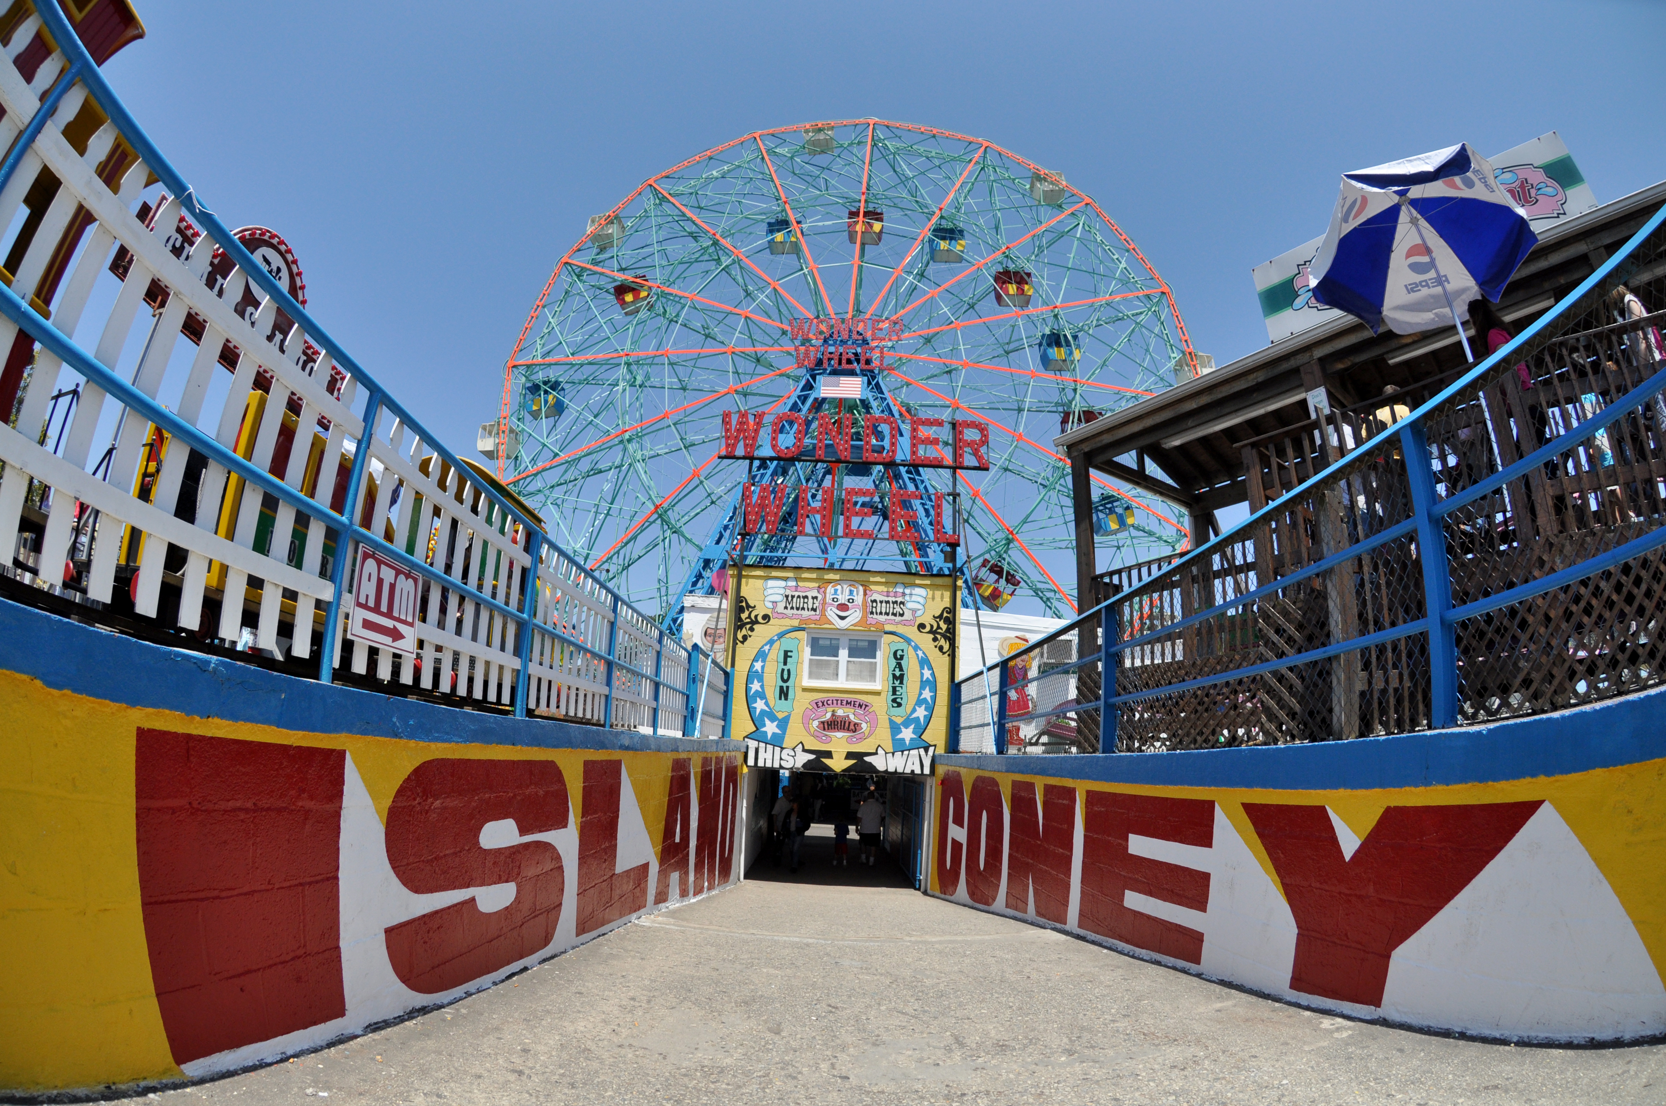

-Part II-

Eighteen

Somewhere between
San Francisco
Oakland
George the stripper
teaching her how
to apply red lipstick
Stayin Alive
Lets Get It On
Brooklyn
Hustlers and hustling

She noticed she was beautiful.
Capable beyond red lined lips
measure
or money.

Costume Shop

Looking for a job used to be easy
just walk around, find a place
where interesting people are
and beg for work.

In Dance Art
floor boards creaked under
pink, black and silver feather boas hung
from a twenty foot ceiling
sharing space with hundreds of glittering stage costumes.

From Broadway dancers to discount strippers
this was the place
in San Francisco.

Rolls of multi-colored sequins and
shiny stretch fabrics
spread out on countertops where dancers
tossed their G-strings and cover-ups
to be measured by the inch
foot or yard.

Sparkling make-up lined the counter upstairs
where George used fat brushes to create
illusions of high cheek bones
near the cash register where I used
4 dollar and 99 cent keys
to ring it up.
Coney Island

F train
Beach 8th Street stop at
Nathans for some cheese fries
lemonade and
cotton candy.
Bumper cars
break dance
Cyclone motors
pump up the volume
3 times.
Cyclone motors
grind and groan
click and roar
climb steel mountains as
sea gods witness
arms stretched into dark skies
screaming
before the drop
drumming old drones
sending us
spinning
back and forth
back and forth
into memories.

Us

We ate artichokes together
on East 13th.
Your first time with this vegetable
prompted you to say,
It might choke Artie but it ain’t gonna choke Stymie.

I showed you how to strip the leaves with your teeth
You showed me how to make coffee in a sock.

We ate cuchifritos together
on East 102nd.
Way past midnight
surprised they are still open
surprised we walked all the way here
surprised by the appetites in our mouths
for this.

On Stanton Street
we never went for the tacos
more for the margarita machine
that dispensed small-medium-large
but we always got the large.
You told me,
El Sombrero
means The Hat in Spanish
but I already knew
what all this meant.

Then it was
El Castillo de Jagua on Rivington
where the smell of pork chops
took away my vegetarianism
as the juices rolled down my chin.

Taste this eggplant fried in batter
Taste this coffee strained through a sock
taste this tasteless, tasteless gin
again and again
this tasteless gin.
We stopped going out to eat.

old sensations
disturbed you
distorted me and
disrupted us.

Atonement

Upon receipt of your generous check
your amends have been gratefully
acknowledged
however
we must bring to your attention
the matter of
your lack of interest
accrued
daily
weekly
monthly
and on an
annual basis.

Years and
silent, rage filled years
intermittently broke into
a robbery of feelings
occasionally stolen tears
fled like lead from my
mouth.

Time

Not so easily assessed
because unlike debt
loss
cannot be cancelled.
The Party

Watchful trees
bend their arms to the sky
a sea of clouds
wander gently by
breathing in the branches.

A balloon
remains stuck
wedged
in between
its feeble attempt
to leave the party.

Almost Dia de los Muertos

Riding through Brooklyn
Vicki pulls out a cigarette
You don’t mind, do you?
Rolls down the window
and lights up.

How could I object?
Grandma’s leftover butts
were ringed with red lipstick
I couldn’t wait to be like her.

Mom suspected
I was stealing her cigarettes
so she offered me one
every time she picked up the pack.
Her gambit worked.

In clubs
I’d light one off Vicki’s
in a chain of smoke
that hasn’t killed us yet.

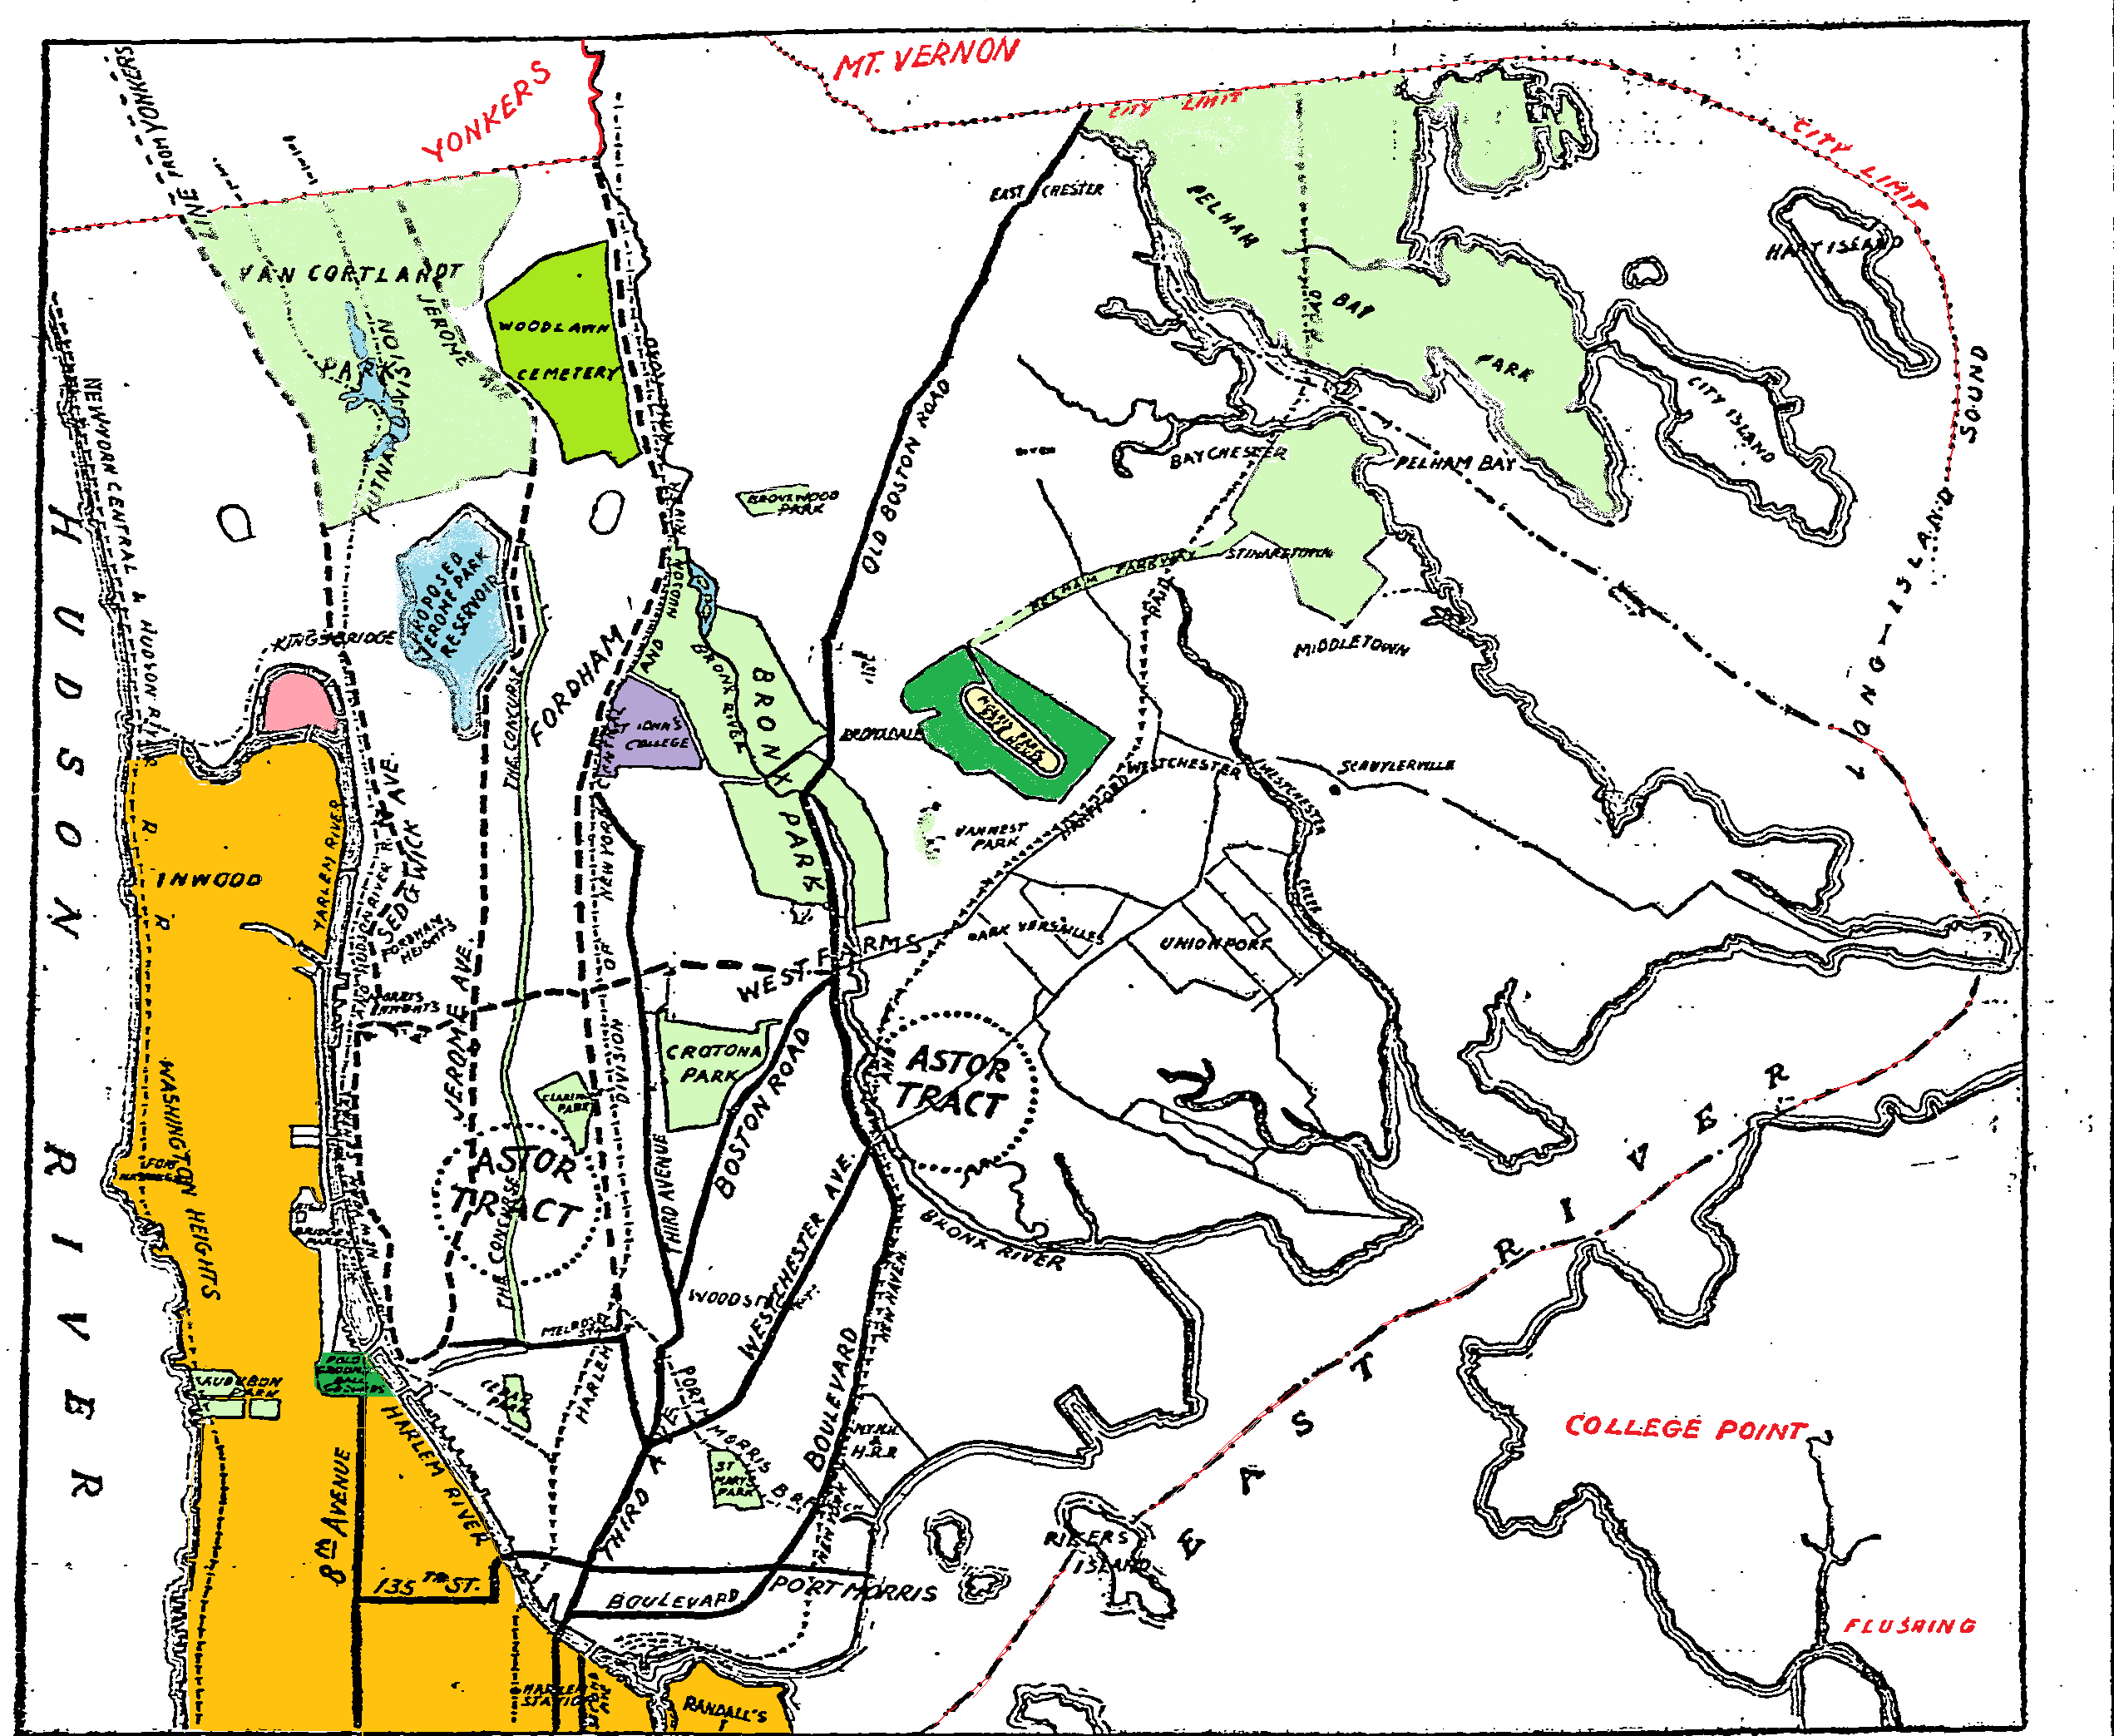

-Part III-

Where I Live

Mostly known as the place
where a neighborhood burned down
Yankees win
cuchifritos sell
coconut ice
sugar cane grows under
the Bruckner overpass
and almost a quarter million people
live in poverty.

I live in
the other Bronx
mostly known as the place
where New York Times
land quietly on porches
where trees outnumber stray cats
and toys left outside
under bird feeders
are still there
in the morning.

On the #1 train to Van Cortlandt Park
I close my eyes and see the Weichquaeskeck.
A Lenape woman
killed for taking a peach,
graves under a parade ground
as native feathers from
Indian Field
flood this subway car.

I hold tight
to keep from falling
on one side
or the other.

Journey’s Song

A three foot tall grin
busts right through you
struck deep by the wide-eyed
alarming stare
I forget she just turned six.

Her cautious joy
introduces, Jayce
a new baby brother
born into this Bronx
shelter, last week.

The mic! Did you bring the mic?
I need the mic!
Can we write poems?

Her words will soon amplify.

I remember that a pencil
and paper do not contain solutions.

We go to the table anyway.
Safety Precautions

This morning I sprayed perfume
behind my ears
made a pot of soup
with lots of onions and garlic
not for the taste
but because maybe,
maybe the vegetables will protect me.

I fill up with twenty dollars of gas
allowing me to maintain the illusion
that there will be enough
to get away if I have to.

After lunch with friends
who talk way too much about sex
fear descends,
the conversation turns to fuzz
and I can’t seem to finish the meal.

Sometime last year,
yesterday
this morning
last month
a few weeks ago or
at 9pm tonight
I might find a way
to get rid of this fear.

Bacon frying
cigarette smoke
baby powder
whether or not I occupy
the kitchen,
the back porch
or Washington, D.C.
the smell of fear consumes my nostrils.

Breathe in
potential catastrophes
Breathe out
potential devastation
Breathe in
potential emergencies
Breathe out
potential disasters

And yoga doesn’t help
when it gets like this.

I still look for ways to protect myself
tonight
even as I make tissue paper butterflies
even as I make dinner
even as I smile at you.

Fertilization

The cycles of our disembodied love
begin again
it’s 10pm and you rush home to me
tired but ready
and so am I.

But the lights stay on tonight
as we prepare the cocktails:

40 amps of Pergonal
60 amps of Gonal F
40 amps of Follistem
intramuscular injections go into the syringe
and into my leg

Should we put some music on?

It’s just right
when you stick me again, but
careful, be careful
my bruises are sore

But that’s alright – I’m alright
cause baby, baby we want a baby
and for you I’d do anything.

Five hard nights we love each other
this way
and finally the day is here.

In your room
you are excited by the photographic image of a stranger.

In my room
I slowly melt into a shot of Demerol
my drug induced puffed up ovaries
are sucked dry of their eggs.

Finally we mingle as composite
in a Petri dish surrounded by prayers
and fluorescent lights.

We are exhausted by this love
that has not allowed us to touch.

Observation is the embryos
are growing and three days later I am inoculated
by us from a parallel universe.

We watch our love enter me
on a black and white monitor with
cheering from a friendly staff of
green-robed technicians.

And now we wait
wait to see if our love grows
or not.

And I admit that I was faking it.
And I admit that I love Demerol.
And I admit that I am praying for a miracle

in spite of the odds against us.

The Game

Lower East Side New York
I’d shave half my head often
unsure at the time
if long hair
gave me more power
or not.

I instructed the barber,
Only the left side.

I save my son’s first hair-cut
in a tiny envelope
glued to a page
in a blue baby book.

Now and then I take some out
gently
as I am certain
of its power.

Last night we played
the game you got for your birthday,
I was sure the answer was
“straw”.

Feeling nervous like
I always do
when we play a new game.

Suddenly,
I changed my answer to
“Hair”.

Correct.
I moved ahead 2 squares.

My hair grows long again
I slowly comb
through the beauty and wreckage.

Steady, unwavering
length of time
changes the game.
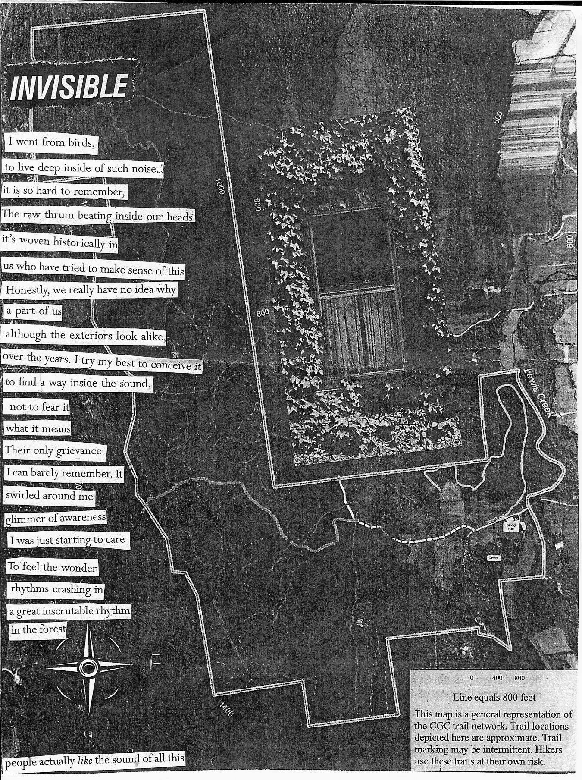

What the Poem Can’t Do

The poem cannot
wash clothes
mop the floor
pack a bag or
make this bed.

The poem does not
whisper, eres muy bonita
dance to, Let’s Stay Together
share a meal at the diner after
or dream about us
the night before.

The poem will not
put music on
light a candle
take my hand
pull me close or
wrap arms around me.

The poem remains fixed to a page
unedited, historic fact. This crumpled paper poem
falls from my hand.

I get my coat
and head out.

Judge This One

Judge this one
but don’t tell me how I rated
don’t measure up these words at all
as my mental state depends on
the ink in my pen that’s
almost gone
holding on
in spite of the noise
that’s in my head
what’s finally led
me here to you.

I give away my power
almost everywhere I go
and every chance I get
this means:

It doesn’t matter who you are
or even if we’ve met.

Your approving or your disapproving
sideways glance or stare
carries a weight within it
that you may not even be aware
of
and incites in me a turmoil
that’s insidiously unfair.

I give away my power
almost everywhere I go
and every chance I get
this means:

Your judgment and speculations
carry highly influential information
still casting out
approval seeking urges
that leave me on the verges of
insanity.
so –

please don't rate me
as the potential still exists
to give away my power
or for me to call it quits

and go on Prozac.

A Letter to Myself

I am writing this urgent letter to you today
before you start washing clothes
cleaning floors
dusting, cooking
moving furniture around
being nice
returning calls that lead to drama
weeding a garden that’s gone to fallow
like human things gone to fallow
like all the things I’m always doing first.

You cannot go back
now that you know
you cannot fix it
change it
flip it
trip it
trick it
sleep through it or
waste too much more of your life
on it.

This is an URGENT letter to you
a very important matter
it cannot wait any longer.
Feels like almost sex
real life feels like almost sex
real people feel like almost sex
not sure if this is almost sex
so I’m writing this letter because I think you should know
that you already do.
Sincerely,

In Relation

Whenever the way I see
where I’m from, changes
where I’m from, changes.

In relation to where you’re from, changes
in relation to where we’re from
and where we are, especially
in relation to where we might
go.
The Moment Everything Changes
A letter to the man who will kiss me

First you should know
I can’t remember how.

I’ve waited for this moment
my thirst for it
deeper than the flesh
of parted lips.

I hope we start slowly,
gain momentum
lose our way
from conversations
spin past prison walls
letting go
crashing
into quiet breathing.

Our lungs fill
empty, fill
empty,
embracing shoulders
nape of neck
tip of ear
and across my deserted cheek
until
our mouths tip
into each other’s ocean
waves advance
recede and
interweave
liberating us from
where bodies end.

I hope
you will
help me
remember
how.


About the Author

Sally DeJesus is a mostly self taught poet, mixed media artist and optimist. Currently, her work includes creating and facilitating poetry/art programs with children and mothers living in a homeless shelter, teaching art in pre-K classrooms, and prose/poetry writing. She has run youth art programs for the Ethical Culture Society, founded a kids’ Social Action Camp, published poetry in Manhattan Linear, exhibited mixed media sculpture in Longwood Art Gallery’s twenty-five-year contemporary and a solo show at RYSEC. Sally won first place at the 1998 Yonkers Public Library slam, is a regular open mic participant in NYC, and has been a waitress, costume shop employee, and video graphic engineer. She juggles the needs of a constant stream of international students who board with her and like her cooking. She enjoys writing and reading poetry, collecting maps, up-cycling and finding new things to be hopeful about.

Contact info:
candidhumans@hotmail.com
347-776-1114

Copyright © 2015 by Sally DeJesus
All rights reserved
Printed in an edition of 50.
This is number .

